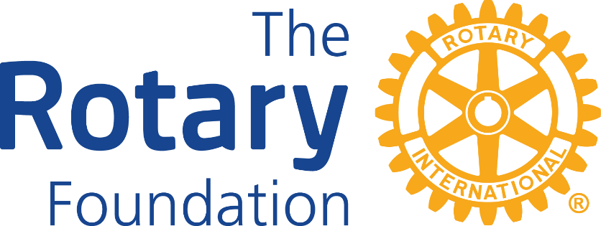

2025-26 ROTARY DISTRICT 5960
KEY DATES FOR ROTARY FOUNDATION RELATED EVENTS

GRANTS MANAGEMENT SEMINARS
Thursday, March 20, 2025 - 7:00-8:30 pm
Saturday, March 22, 2025 - 9:00-10:30 am
Monday, March 24, 2025 - 3:00-4:30 pm

GLOBAL GRANTS WORKSHOPS
Thursday, March 27, 2025 - 7:00-8:30 pm
Monday, March 31, 2025 - 3:00-4:30 pm

SHARK TANK
Wednesday May 7, 2025 4:00-5:30 pm

2025-26 GLOBAL GRANT SUBMISSION DATES
Deadline for project submission: Friday, May 16, 2025
Project review date: Friday, May 30, 2025 - 1:30-3:00 pm

2025-26 DISTRICT GRANT SUBMISSION DATES
Deadline for project submission: Friday, May 30, 2025
Project review date: Friday, June 13, 2025 - 12:30-2:30 pm

All trainings and presentations will be conducted via Zoom

